Context task
- Do you exercise regularly?
- What kind of exercise do you do?
- Why is exercise important?
Exercise relaxes our body and mind.
Exercise lowers stress and helps us to sleep better.

Task 1 – How you can exercise
What exercise is free and easy to do? Which one would you like to do?

  5  6  1  2  8  3  7  4 | 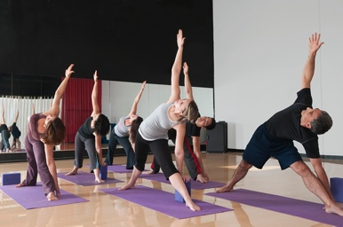 | 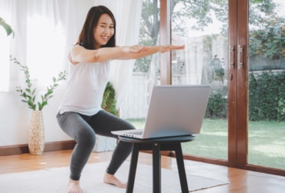 | 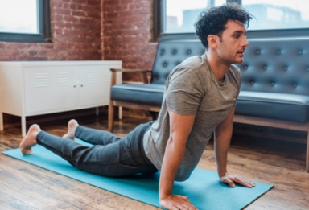
 | 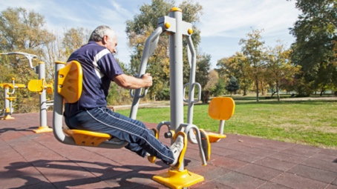 |  | 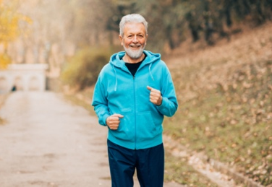

Look at the pictures above and match them to the activities below. The first one has been completed for you as an example.

7 | Put on music and dance |  | Go for a run. |  | Use an outdoor gym. |  | Do a free online class.
 | Stretch your body at home. |  | Take the stairs, not the lift. |  | Walk in the park. |  | Join a free local exercise class.
Read the activities again and fill the gaps with the verbs - the first one has been completed for you.

Go
Put Use Join Walk Take Do Stretch
Walk in the park.
the stairs, not the lift.
for a run.
a free local exercise class.
a free online class.
an outdoor gym.
music on and dance.
your body at home.

Task 2 - Benefits of exercise

  1 |   2 |   3
Physical body | Mental mind | Emotional feelings
Choose if each statement below is either physical (1), mental (2) or emotional
(3). The first one has been completed for you as an example.

strong muscles | 1 | more energy
feel happy |  | relaxed
feel more positive |  | better sleep
lower stress |  | strong heart
better concentration |  | strong bones
better memory |  | flexible joints

Task 3 – Read about exercise
Read the text and answer the questions - the first one has been completed for you.
Exercise is good for your body, mind and emotions. When you exercise, your heart gets stronger, and you have more energy. It helps you sleep better and lowers stress. Exercise can also make you feel happier. Regular exercise helps you stay healthy and can even help you live longer. Try to find an activity you enjoy and make it a regular part of your weekly routine. Try to exercise 5 times for at least 30 minutes every week.

 | True | False
Exercise does not have many benefits. |  | X
Exercise gives you energy.
Exercise lowers stress.
Exercise makes you sad.
Exercise helps you stay healthy.
You should exercise once a month.

