Task 1 - Feelings vocabulary
Match the word or sentence to the picture. The first one has been completed for you.

 |  |  | 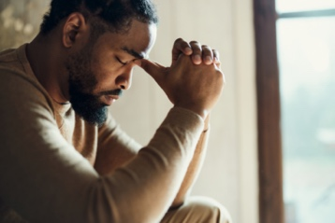
tired
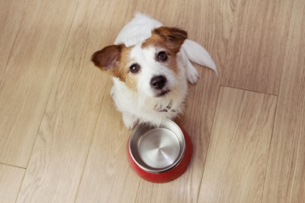 | 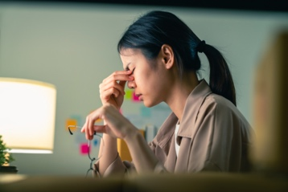 |  | 
 |  | 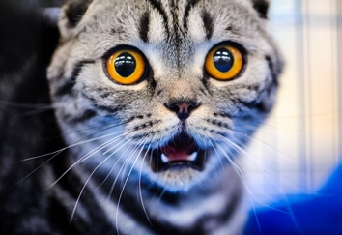

scared | sad | angry | bored
worried | tired | happy | hungry
sick | stressed | thirsty

Task 2 - Sentences about feelings
Look at the pictures from task 1 and form sentences. The first one has been done for you.

 | He is tired

Task 3 - How do they feel?
Write the correct word. The first one has been completed for you.

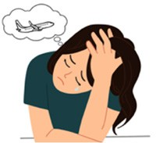 | How are you today, Laura? | I am sad .  My brother is going back home.
 | Happy birthday, Rabya! | I am .  I got some amazing presents.
 | How are you today, Mark? | Oh, I am still very . I have a high fever.
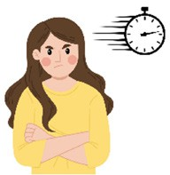 | How are you, Kelly? | I am . My friend is late again.
 | How are you, Pablo? | I am . I am alone at work today.
 | Hello, Ethan. How are you? | I am . I have been for a run.
 | How are you feeling, Aliya? | I am feeling . I didn’t sleep well last night.
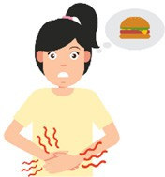 | Hello, Elena. How are you? | I am .  I want to eat a big burger with chips.
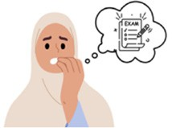 | Hi Amadou, are you okay? | No, I am very . My exams are tomorrow.
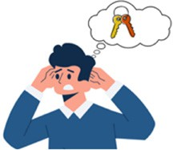 | How are you, Ali? | I am today. I cannot find my keys.
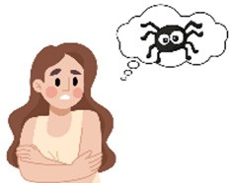 | Hi, Gurpreet! How are you? | I am . I saw a big spider.

Task 4 - Checking feelings
Read Task 3 again and circle the correct answer. The first one has been completed for you.
1. Is Laura happy? | Yes, she is. | No, she isn’t.
2. Is Rabya happy? | Yes, she is. | No, she isn’t.
3. Is Mark sick? | Yes, he is. | No, he isn’t.
4. Is Kelly angry? | Yes, she is. | No, she isn’t.
5. Is Pablo bored? | Yes, he is. | No, he isn’t.
6. Is Ethan thirsty? | Yes, he is. | No, he isn’t.
7. Is Aliya tired? | Yes, she is. | No, she isn’t.
8. Is Elena hungry? | Yes, she is. | No, she isn’t.
9. Is Amadou worried? | Yes, he is. | No, he isn’t.
10. Is Ali stressed? | Yes, he is. | No, he isn’t.
11. Is Gurpreet scared? | Yes, she is. | No, she isn’t.

Task 5 - Time to relax
Sometimes we need to relax. Here are two activities you can try alone or with your teacher. When you feel that things are getting too much, take a few minutes and try to think of:
5 things you can see 4 things you can touch 3 things you can hear
2 things you can smell 1 thing you can taste
Creating happy moments
Thinking about the things that you are thankful for is called gratitude. Thinking about those things regularly can help you feel happier.
Can you think of one thing that you are thankful for? Ask yourself this question every day in the morning or before you go to sleep.

