Context task A B
Look at pictures A and B. Which picture shows healthy food and which one shows unhealthy food? Why? | 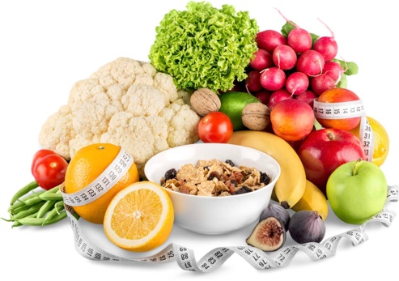  A | 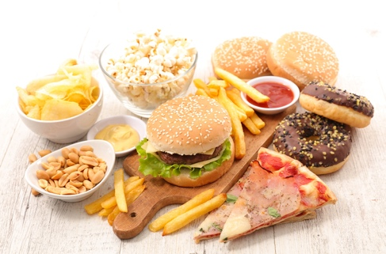  B

Task 1 – Types of food
Match the vocabulary to the definitions and examples. The first one has been done for you.

Vocabulary | Definition/examples
1. poultry | a. produced, manufactured
2. pulses | b. chicken, turkey, duck
3. grains | c. healthy eating plan
4. processed | d. beans, lentils, chickpeas
5. balanced diet | e. wheat, rye, oats, bulgur

Task 2 – Food group
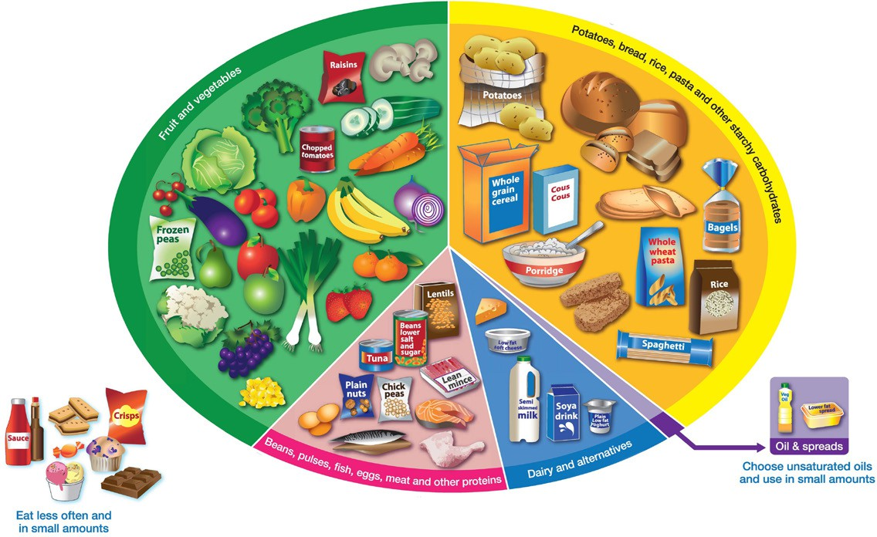

Image adapted from The Eatwell Guide from Public Health England.
Look at the plate and read about the main food groups. They show a healthy balanced diet. The plate shows how much of each food you should eat – not all at once!

  Fruits and vegetables |   Carbohydrates |   Protein |   Dairy |   Fats |   Ultra processed foods
vegetables | bread | meat | milk | butter | biscuits
salad | pasta | eggs | yoghurt | oil | crisps
fruit | rice potatoes | nuts lentils | cheese | ghee | fizzy drinks
Sort these food items into the correct food group The first example has been done for you.
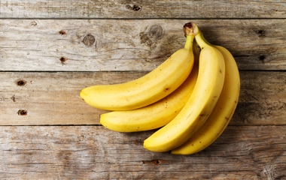  1  2  3  4  8  7  6  5 | 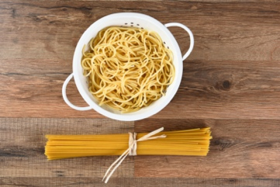 | 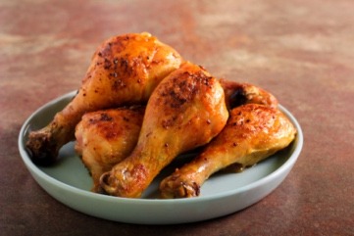 | 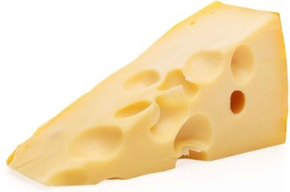
FV
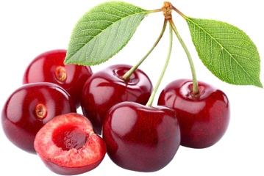 | 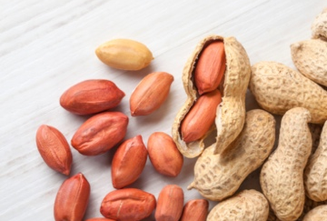 | 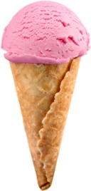 | 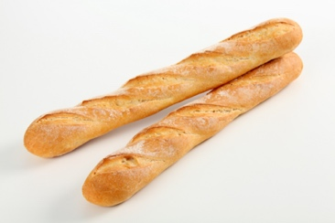

Task 3 – Healthy eating guidelines
Complete the sentences with words from the box. The first sentence has been done for you.
- You should eat five pieces of fruit and vegetables every day.
- You eat fish, eggs and for protein.
- You should a lot of water.
- You should eat 3 regular meals day.
- You should not eat processed meat like or sausages.
- You should not use too much or fat.
- You should not eat too much sugar or .
- You should eat healthy , for example brown bread and rice.

carbohydrates | butter | should | every | eat
bacon | pulses | fruit | salt | drink

