Getting enough sleep helps your body and mind. According to the NHS, one in every three people in the UK don’t get enough sleep.

Task 1 - Sleeping vocabulary
Match the word or sentence to the picture. The first one has been completed for you.

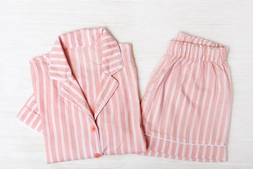  1  2  3  4  8  7  6  5  9 |  | 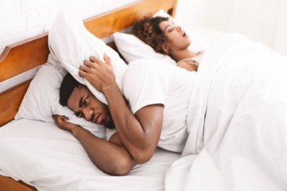 | 
pyjamas
 | 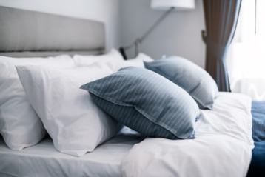 | 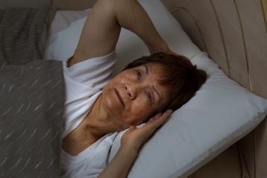 | 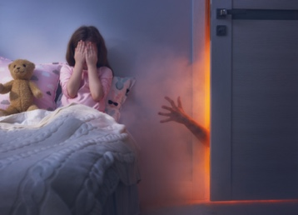
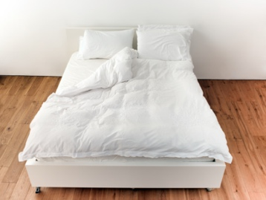

I sleep well | snore | nightmare | pillow | bed
I can’t fall asleep. | dream | pyjamas | yawn

Task 2 - Guide to better sleep
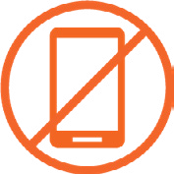 | Don’t use your phone, laptop or tablet before you go to bed. You can relax with some music or a book.
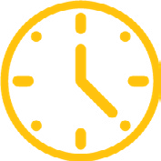 | Set a routine.  Try to sleep at the same time every day.
 | Make your room darker.  Turn off the lights and close the curtains.
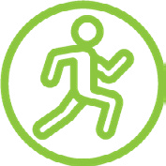 | Exercise during the day.  Exercising during the day can help you sleep better.
 | Eat well during the day.  It’s better not to eat a big meal before going to bed.
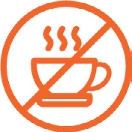 | Don’t drink coffee or tea late in the evening.

Task 3 - Questions about a sleep routine
Answer the following questions. The first one has been completed for you:

1. The lights must be on before I sleep. | YES | NO
2. I should listen to loud music. | YES | NO
3. It’s good to read a book before sleeping. | YES | NO
4. It doesn’t matter what time I sleep every day. | YES | NO
5. I should not use my phone before bed. | YES | NO
6. Watching YouTube videos can help me sleep. | YES | NO
7. I can drink coffee at 9pm. | YES | NO

Task 4 - Breathing exercise
You can try square breathing. This will help you feel calm and may help you sleep better.
- Find a comfortable position.
- Take a few deep breaths to settle into the exercise.
- Breathe in for a count of four while creating a square with your hand.
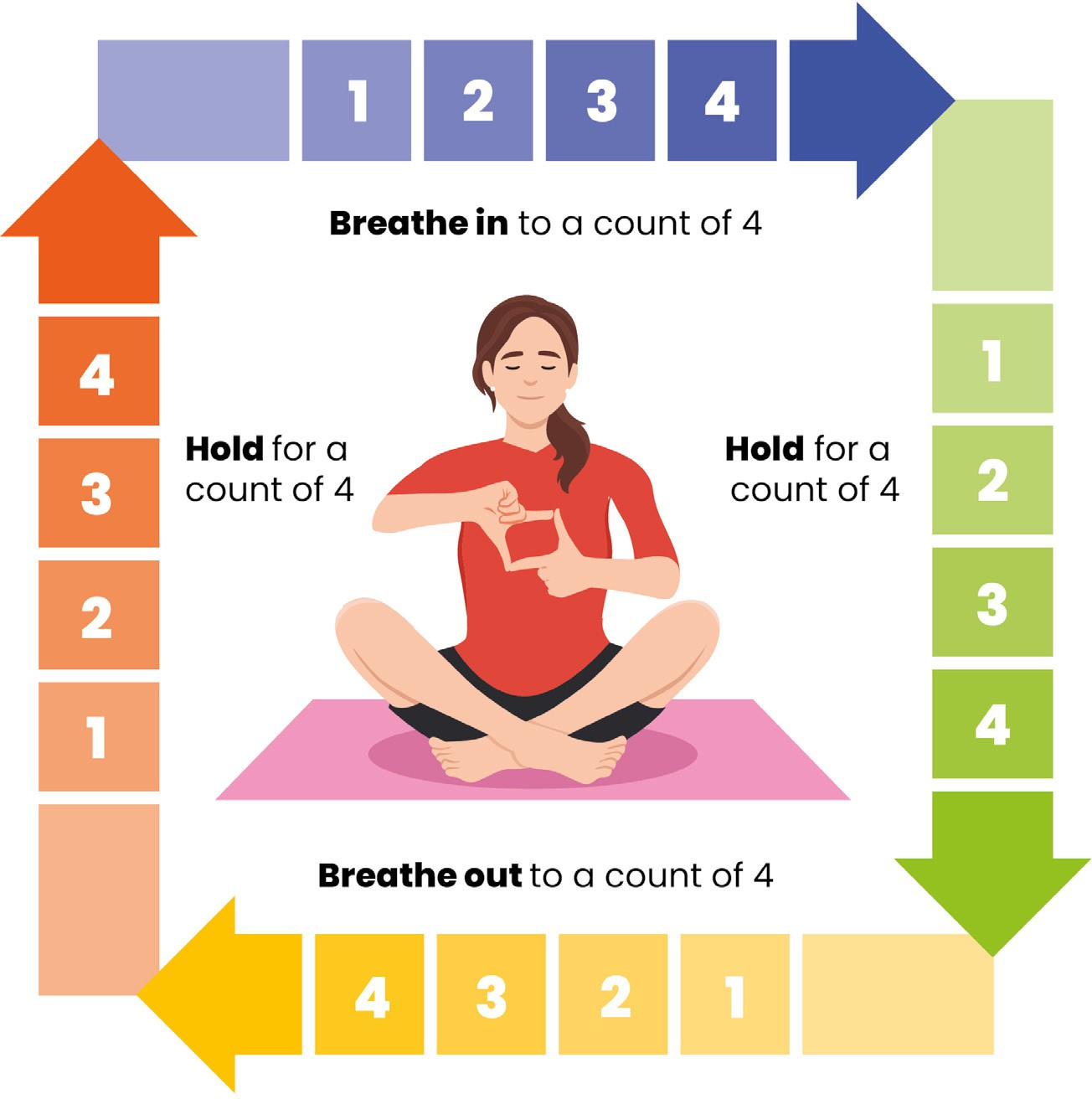

Task 5 - Reflection
Have you learned anything new about sleep?
Can you think of 3 things that you can change to improve your sleep?

- For more information on getting a good night’s sleep watch this film.
https://www.youtube.com/watch?v=nysjq8VIwI8

