Context task - Volunteering discussion
What is volunteering?
 | Helping others and working without getting paid.

Task 1 – The benefits of volunteering
Read the vocabulary and definitions.

wellbeing | feeling good in body and mind
to socialise | to meet new people and make new friends
skills | things you can do (e.g. use the computer, speak English, bake cakes)
community | people who live in your area

Read the sentences below.

- With volunteering, you can help people in your community.
- With volunteering, you can learn new skills.
- With volunteering, you can socialise and meet new people.
- With volunteering, you can feel happy and active.
- With volunteering, you can be part of a team.
- With volunteering, you can practise English.

Match the verb to the sentence. The first one has been done for you.
- With volunteering you can help people in your community.
- With volunteering you can new skills.
- With volunteering you can and meet new people.
- With volunteering you can happy and active.
- With volunteering you can part of a team.
- With volunteering you can English.

learn | be | practise | help | socialise | feel

Task 2 – What you can do as a volunteer
Look at the pictures. Talk about where these volunteers are and what they are doing. Use the words below to help you.

food bank - work | charity shop - work | rubbish - clear
at school - help | older people - help | gardening in park - do

  4  1  6  2  5  3 |  | 
 |  | 

Task 3 – Read about a volunteer
Read the text and answer the questions about Maria.

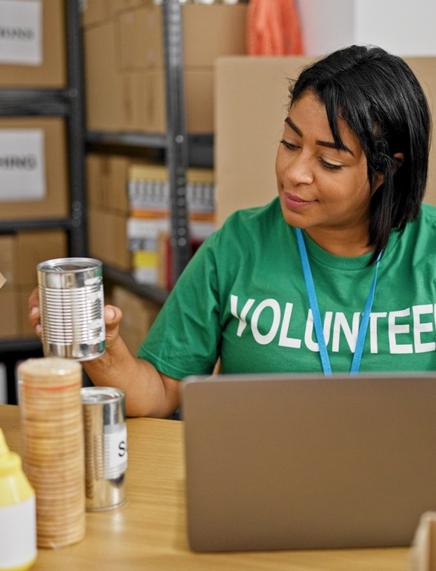 | This is Maria. She is from Ukraine.  She is a volunteer at a food bank. She helps people who do not have enough food. Every Saturday, Maria works at the food bank from 9am to 3pm. She gives food to families. She smiles and talks to them. Maria feels happy because she helps people. She works with other volunteers. They are a team. Maria likes  volunteering because she is helping her community. She gets training. She learns how to pack boxes and uses the food bank telephone. She practises English.

  - Where does Maria volunteer?
  - Which day and time does Maria volunteer?
  - What does she do at the food bank?
  - How does she feel?
  - Does she like volunteering, and why?
  - What skills is she learning?

Task 4 – Volunteering websites
There are useful websites to help you find volunteering roles. Look at these two websites on your phone, tablet or laptop. What volunteering jobs can you find? Which one would interest you?
www.connectedkingston.uk www.volunteeringkingston.org.uk

