Task 1 - Documentation vocabulary
Passport | 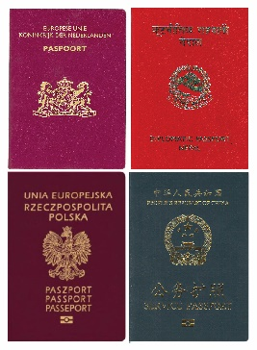 | Shows your country.
Personal details | 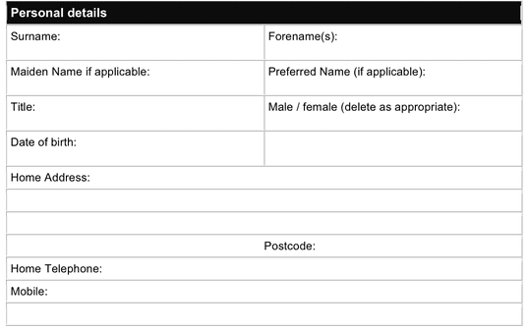 | Shows details about you.
Immigration status | 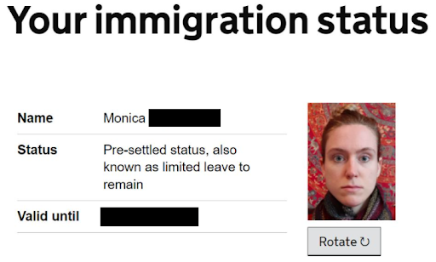 | Shows if you can work, or study, in the UK.  Shows the date it ends.
Right to work | 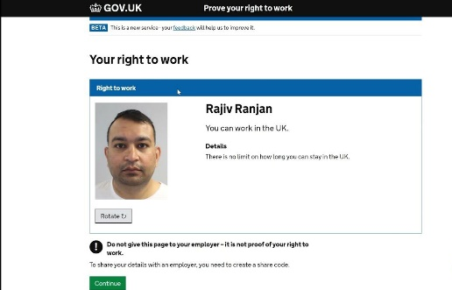 | Shows that you can work in the UK.

Task 2–eVisas
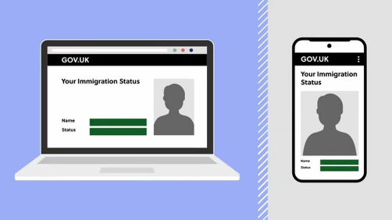 | Shows, on a computer or a mobile phone:  - your passport  - your personal details  - your immigration status  - Your right to work.

Complete the sentences below using the vocabulary from Task 1. The first one has been done for you.
- With an eVisa, you can show your passport. 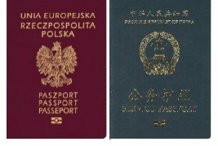

- With an eVisa, you can show your ______/___________ .

- With an eVisa, you can show your __________/_______. 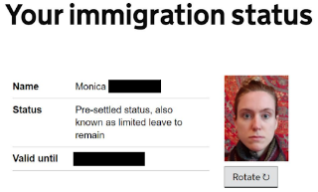

- With an eVisa, you can show your____/___/______ . 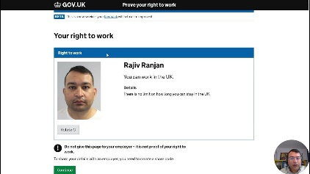.

Task 3 – Share codes

Vocabulary
United Kingdom Visa and Immigration account (UKVI) |  | You get this online. Then you can get an eVisa and share code.
Employer |  | Who you work for.
Landlord |  | A landlord is a person who owns a house or flat and gets money called rent from people who live there

Read/listen to the following and then answer the questions:

A share code is free.
A share code lasts for 90 days.
Go to your United Kingdom Visa and Immigration account (UKVI) to get a share code.
Show a share code to your employer to show you have the right to work.
Show a share code to your landlord to show your immigration status.

- How much do share codes cost?
- How long are share codes valid for?
- Where do you get a share code from?
- Who will you show a share code to?

Task 4 – Universal Credit
Universal Credit is a monthly payment from the UK Government to help people who are on low income or out of work.

 | Money to pay for food, clothing, things needed every day.
 | Money to pay your landlord.
 | Money to help if you have children.
 | Money for someone to look after your child so you can go to work.
 | Money if you are sick for a long time.
 | Money for you if you care for someone 35 hours a week.
 | Money if you are disabled.

Complete the sentences about Universal Credit:

You can get money for someone to look after your___________ so you can go to ___________ . .

You can get money if you have ____________ with you.

You can get money to pay your _____________ .

You can get money if you are ______________.

You can get money if you are ________ for a long time.

Task 5 – Review

- What can your immigration status show?

- What 2 things can you show on an eVisa?

- Who can you show a share code to?

- Name two things you can get Universal Credit for.

- Does the UK Government give you money if you are disabled?

