Task 1 - Homelessness vocabulary

Match the words below to the pictures:

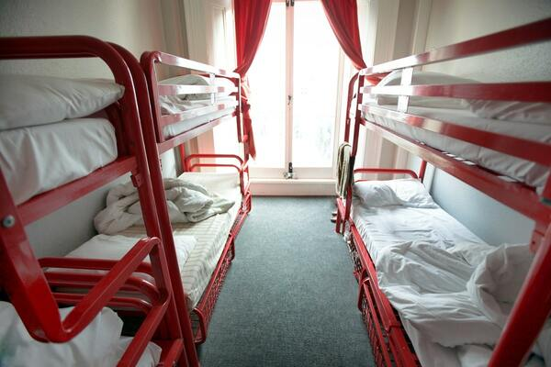  1 | 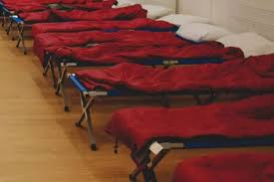  2 | 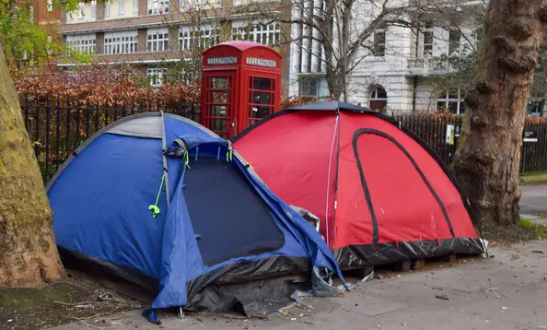  3
  4 | 5 | 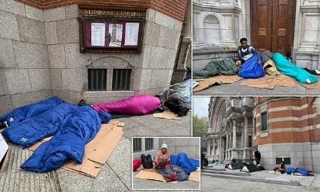  6

sleeping rough | hostel | night shelter
sleeping on the streets | eviction | sofa surfing

Which pictures are linked to homelessness?
6
5
 | yes / no |  | yes / no
1 | yes / no | 2 | yes / no
3 | yes / no | 4 | yes / no

Task 2 – What is homelessness?

Homelessness can happen to anyone. A person does not need to sleep on the street to be homeless.

A person may be called homeless if they are:

living in places that are bad for their health

staying in a hostel or shelter

in danger if they stay in their home

staying in temporary (not long term) accommodation

staying with friends or family. This might be called sofa surfing.

sleeping on the streets

Complete the following sentences:

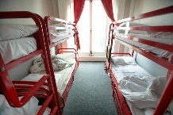
I am homeless because I am staying in a ___________

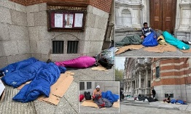
I am homeless because I am ______________ ___ ____ _________

I am homeless because I sleep in a ________

I am homeless because I am __________ __________

Task 3 – Who can help?

Vocabulary

Local Authority / Council | Government for your area
Location | Where you are
Charity | Help people in need
Outreach | People will come to you
Given notice to vacate | Told you must leave your property
Legal proceedings | Going to court
Vacate | Leave
Tenant | A person living in a landlord’s property

If a person has no home, or will lose their home in 8 weeks, their Council can help. They can call and ask for the housing office. Find the council at gov.uk/find-local-council

If someone is sleeping outside, they can tell StreetLink. The local team will try to find them and help.

If a person is homeless, has no place to sleep, or is worried, they can contact Shelter.￼ https://england.shelter.org.uk/get_help￼

Task 4 – Eviction notice

When someone is evicted they will get an eviction notice. This will tell them what will happen next. t. Read the eviction notice below, then write the answers to the questions.
Eviction Notice

Reference Number: Z0987Y Date: 16 June 2025

Tenant Name: Micheal Abbas

Property Address: 12 The Street, The Town, The UK

You are hereby given notice to vacate 12 The Street, The Town, The UK
on or before: 16 July 2025, 30 days from the date of notice.

Reason for eviction: Unpaid rent of £1,500.

Failure to vacate will result in legal proceedings against you.

If you are at risk of becoming homeless because of this notice, you should contact your local authority for help.

Landlord Name: John Smith

Signed by Landlord: ______________________ Date: 16 June 2025

- When was the eviction notice given to the tenant?

- What is the address?

- What should the tenant do if they are going to be homeless?

- When do they have to leave the property?

- Why are they going to be evicted?

Task 5 –Asking for help
When someone asks the Council for help with housing, a homelessness officer checks if they can get help.

The officer will ask:
-About the person’s immigration status
-If the person has lived outside the UK recently
The Council asks these questions even if the person is British.

Role play

A: Hello, this is the Hillingdon Council Housing Office. How can I help?

B: Hello, I’ve been evicted. I am homeless. Can you help me?

A: Where are you living?

B: I am in London.

A: Do you know your local authority, or the town you are in?

B: Yes, I am in West Drayton. The local authority is Hillingdon.

A: OK, you have called the right place. What is your immigration status?

B: I have received refugee status and have the right to remain for 2 years.

A: Have you lived outside the UK recently.

B: Yes, I arrived in the UK 6 months ago.

A: Where do you sleep at night.

B: I stay with friends, family, whoever will let me sleep on their sofa.

Task 6 – Review

Write your answers to these questions below.

- What does the word ‘eviction’ mean?

- If you are ‘sofa surfing’ how are you living?

- Where is the first place you should go for housing help?

- Which charities may be able to help you if you are homeless?

- What does being homeless mean?

Can you guess the words below?
h _ m _ _ _ s s _ _ ss v _ c _ t _
l _ c _ l a u _ _ o r _ _ _ _ _ _ s t _ l
e v _ _ t i _ _ s _ _ _ s _ _ f _ _ _

