Task 1 - Housing vocabulary
Landlord - A person who owns a house or flat and gets money called rent from people who live there.
Tenant – A person who lives in a landlord’s flat or house.
 | Lease agreement (Rental agreement) – A document signed by both the landlord and the tenant.
Private rented property
Housing owned by people and rented to tenants. This can be a room or a whole property.
 | Temporary accommodation – A room normally used for a short time.
 | Council housing – Flats or houses, normally for people with children, owned by the local authority (council).
 | Asylum accommodation - Temporary housing for those seeking asylum, often in hotels.
 | Hostels – Many people in the same room. It is normally used as temporary housing.
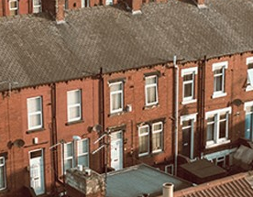 | House – A building on its own land.  Flat – part of a building that contains many individual living spaces.
 | Rent – The amount of money you pay each month for housing.
 | Universal Credit – Money the government give you if you’re unemployed, too ill to work or on a low wage.
Type of place to live

If you need a place to live, you can rent a room or a flat. You can stay in a:

Shared house – You have your own room. You share the kitchen and bathroom.
Room in a house – You rent one room.
Flat, apartment or house - You may live alone or with your family.

Task 2 –Housing vocabulary

Find the words hidden in the wordsearch puzzle.
l | a | t | e | b | o | r | d | c | d
f | e | e | f | g | h | i | j | k | l
l | a | n | d | l | o | r | d | m | n
a | o | a | p | q | r | r | e | n | t
t | s | n | t | u | v | w | x | y | e
z | a | t | b | h | o | u | s | e | m
c | d | e | f | o | g | h | i | j | p
k | l | m | n | s | o | p | q | r | o
s | t | u | v | t | w | x | y | z | r
p | r | o | p | e | r | t | y | a | a
b | c | d | e | l | c | f | g | h | r
u | n | i | v | e | r | s | a | L | y
a | e | i | o | u | E | a | a | e | y
e | e | f | d | r | d | c | t | a | m
t | y | a | b | c | i | c | e | s | a
b | s | a | e | o | t | i | o | e | u
c | o | u | n | c | i | l | s | a | x

landlord | flat | tenant | house
hostel | rent | temporary | property
credit | universal | lease | council

Task 3 – Looking for housing

Fill in the gaps using the vocabulary you have learnt.

__________ are used for temporary housing.

I will sign a ____________ ______________ with my landlord.


People pay ________ to my landlord.


people can get _______________ _____________ from the government if I am not working.

If you can, add your own sentence below, using the vocabulary you have learned.
_______________________________________________________
_______________________________________________________

Task 4 – Finding housing

Where would you look for housing? Link the pictures to the words.
Look online |  | 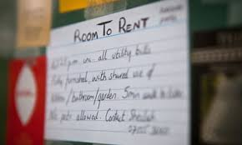
Look in shop windows |  | 
Look in local papers |  | 
Ask friends |  | 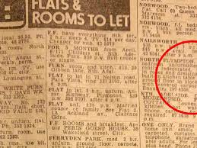

Can you think of other places where you can look for housing? Write them here:

Charities that may be able to help with housing:
Refugee Council https://www.refugeecouncil.org.uk/
London Lettings Network https://lettingsnetwork.housingjustice.org.uk

Task 4 – Visiting housing
In pairs practice making a call to the landlord to see a place to live.

Landlord: Hello
Tenant: Hello, I am calling about the room.
Landlord: Yes
Tenant: Is it still available?
Landlord: Yes, it is.
Tenant: Do you take Universal Credit?
Landlord: Yes, but only if it is paid to me, not you.
Tenant: Does the rent include bills and WiFi?
Landlord: It includes council tax, electricity, gas and water but not WiFi.
Tenant: Can I come and see the property next week?
Landlord: No, I can only show you it today after 7pm.
Tenant: OK I will be at the property at 7.30pm today.

Now answer the following questions

- Is the flat available?
- Does the landlord take people who pay with Universal Credit?
- Does the rent cover all the bills?
- When can the tenant visit the property?
- Is the tenant going to see the property?

Task 6 – Review

- What is Universal Credit?

- Who signs a lease agreement?

- Give 3 ways you can look for housing.

- Give one charity that may be able to help you find housing.

- Move these letters to find rooms you find in flats and houses.

omedrob | chnetki | rinoingdmo | omrlvngiio

