Task 1 – The library

A library is a building with many books. You can read books. You can borrow books to take home, but you must return them to the library. You can use computers. It is quiet in the library. It is free to use the library.

Vocabulary

building | 
books | 
home | 
computers | 
library | 

Read the sentences below.

Select the word from the vocabulary above to complete the sentences. Some words you may have to use more than once.

A _____________  is a _______________  with many ____________ . You can read _____________ . You can borrow______________ to read at___________ . To borrow means you will take them back to the ____________ .
You can use ________________  . It is quiet in the _______________.

Task 2 - How to join the library
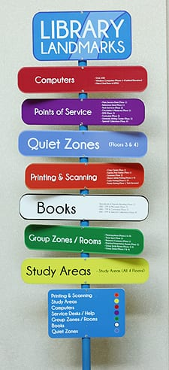
To use the library, you'll need to visit the library to collect your library card with something that shows your:

name
address

You fill in a form with your name, address, and phone number.

You get a library card.
Now you can borrow books.
Practice filling out a form for the library:
Title: Mr Miss Ms Mrs Other:
Surname
First names
Date of birth
Postcode
Email address
Telephone Number



Task 3 – Jobcentre

The Jobcentre is a place to help people find work. It is free. Anyone can go in.

At the Jobcentre you can look for jobs on computers.
At the Jobcentre you can write a CV, a paper about your work and education.
At the Jobcentre you can prepare for job interviews.
At the Jobcentre you can get help with how to claim money if you do not have a job.
At the Jobcentre you can learn new skills.

Complete 5 sentences about what you can do in the Jobcentre. Start each sentence with ‘I can….’. The first sentence has been done for you.

- I can look for jobs. | look for jobs
2. | write a CV
3. | prepare for job interviews
4. | claim money
5. | learn new skills



Task 4 – Citizens Advice

- You can go to Citizens Advice at their offices or online to get free help.
- You can get help with money, housing, work and immigration.
- They will keep what you say private.
- They can help everyone.
- They can help in other languages.

How can you contact Citizens Advice? Match the word to the picture:

 |  | 
Phone | Email | In their offices

Questions. Answer these questions about Citizens Advice:

1. | You can contact Citizens Advice in their offices. | true | false
2. | You can phone Citizens Advice. | true | false
3. | You can email Citizens Advice | true | false
4. | You can get advice in other languages. | true | false
5. | You can ask them about immigration. | true | false
6. | You can get free help. | true | false

Task 5– Review

- What can you find in the library?
_______________
- You want help to write your CV, where can you go?
_________________
- You have questions about your immigration status, who can you contact for help?
________________________________
- How can you contact Citizens Advice?
  ____________ |   _________________
- You are learning English, where can you get books to help you learn?
____________________________

