Task 1 - Documentation vocabulary
Passport | 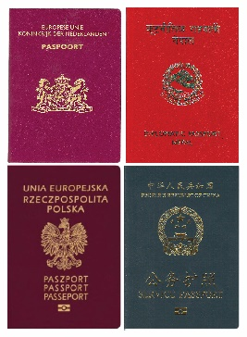 | Shows the country you are a citizen of. People can have more than one.
Personal Details | 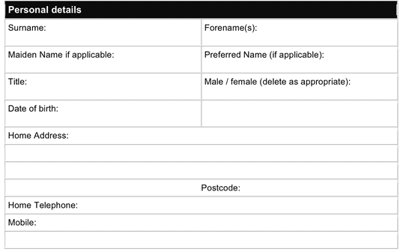 | Shows details about you.  Most forms will ask for this information
Immigration Status | 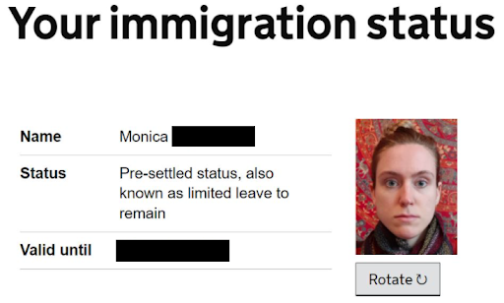 | Shows if you can live, work, or study in the UK.  Shows the date it ends.
Right to Work | 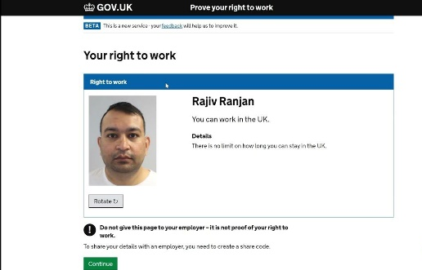 | Shows that you can work in the UK.

Task 2 – Verbs

A verb is a word that shows an action. It is sometimes called a ‘doing’ word.
 |  |  | Verbs are used in every sentence to say what someone or something does or is.
Examples
 | Show | You can show your passport.
 | Get | You get your immigration status from the Home Office.
 | Work | You have the right to work.
 | Study | Your immigration status shows if you can study.

Identify the verbs in these sentences. Underline them. Write your answers underlining the verbs you use.

- What shows which country you are a citizen of?

- Where do you get your immigration status from?

- How can you show you can work in the UK?

Task 3 – eVisas

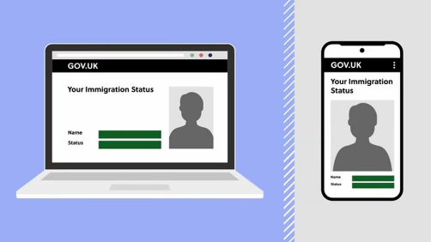 | Shows, on a computer or a mobile phone:  - your passport  - your personal details  - your immigration status  - Your right to work.
Complete the sentences below inserting a verb in the gap from the verbs below.

show | write | work | live | study

- I can ___________ my right to __________ on my eVisa.

- I will have to __________ my personal details on many forms.

- My immigration status gives me the right to ___________ in the UK.

- I am in the UK to ___________ at university.

Task 4 – Share codes

Vocabulary

United Kingdom Visa and Immigration account | UKVI – You get this online. Then you can get an eVisa and share code.
Employer | A person or company that you work for.
Landlord | A landlord is a person who owns a house or flat and gets money called rent from people who live there

Read/listen to the following:

A share code is free and can be shown for 90 days. After that you can get a new one. Once you have set up your United Kingdom Visa and Immigration (UKVI) account you can get a share code. You will need to show your share code to your employer. This shows you have the right to work in the UK. If you study in the UK, you will show the share code to your university. If you are living in the UK, you show a share code to your landlord to show your immigration status.

Now underline all the verbs you can find in the writing above.

Write 3 sentences about what share codes can be used for.

1.

2.

3.

Task 5 – Universal Credit
Universal Credit is a monthly payment from the UK Government to help people who are on low income or out of work.

Underline all the verbs you can find in the exercise below. The first one has been done for you.

Remember

A verb is a word that shows an action or a state of being. It is sometimes called a ‘doing’ word.
Verbs are used in every sentence to say what someone or something does or is.

 | Money to pay for food, clothing, things for every day.
 | Money to pay your landlord.
 | Money to help if you have children.
 | Money for someone to look after your child so you can go to work.
 | Money if you are sick for a long time.
 | Money for you if you care for someone 35 hours a week.
 | - Money if you are disabled.

Add the missing verbs to these 3 sentences about Universal Credit:

You can _____ money for someone to _______ ______ your children so you can go to ____________.

You can ______ money if you have children with you.

You can ____ money if you are _________________.

You can apply for Universal Credit online. https://www.gov.uk/universal-credit/how-to-claim

Task 6 – Review

- What is a verb?
- Do the UK Government give you money if you are disabled?
- Who can you show a share code to?
- Name two things you can get Universal Credit for.
- Write 2 sentences about documentation in the UK underlining the verbs.

