Task 1 - Homelessness vocabulary

Match the words below to the pictures:
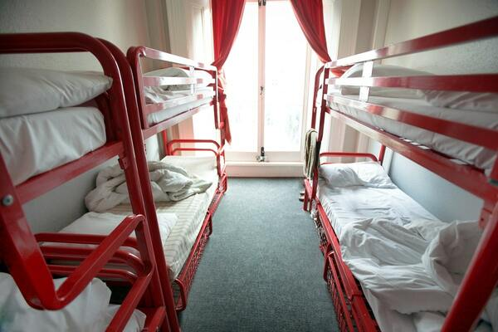  1 | 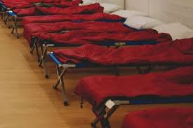  2 | 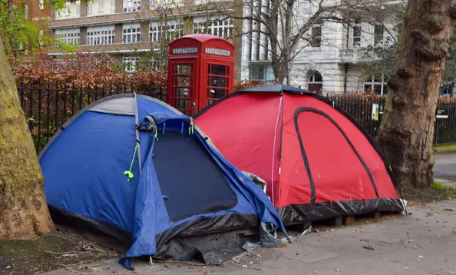  3
  4 | 5 | 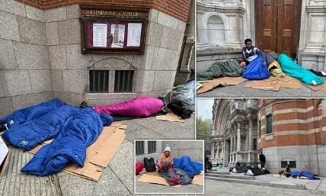  6

sleeping rough | hostel | night shelter
sleeping on the streets | eviction | sofa surfing

All the people in the pictures above are homeless.

Complete these sentences using the vocabulary above.

He is ______ _______, moving regularly to sleep with friends and family, because he is homeless.

He is _____________ ___ ____ ________ with no shelter or privacy because he is homeless.

The people here have an ___________ notice. They will have to leave the property.
Did you know 4.500 people sleep rough in England every night?

Task 2 – What is homelessness?

Grammar Focus: Present Simple and Past Simple tenses
Present Simple:
We use it for:
1. Things that are always true
Example: 'I live with my family.'
2. Habits or routines
Example: 'On Saturdays I stay at my Aunt's house.'

Past Simple:
We use it for: Things that happened in the past. Examples:
- I lived on the street last year.
- He stayed in a shelter.

Underline 3 present simple and 2 past simple verbs (action words) in the sentences below:

People are homeless if they sleep outside or live in hostels.
Ahmed lives in a shelter. Before, he slept outside.
Last year, Maria lived in a hostel.

Now complete the following sentences using past or present tense:

- I _________ with my brother now. (live)
- I __________ in a shelter last year. (stay)
- I __________ in a small flat. (sleep)
- Last year I ___________ in a park. (live)

Task 3 – Who can help?

Vocabulary Match the word to the definition
Local Authority / Council |  | Where you are
Location |  | Government for your area
Charity |  | Told you must leave your property
Outreach |  | A person living in a landlord’s property
Given notice to vacate |  | Going to court
Legal proceedings |  | Help people in need
Tenant |  | People will come to you

If a person has no home, or will lose their home in 8 weeks, their Council can help. They can call and ask for the housing office. Find the council at gov.uk/find-local-council

If someone is sleeping outside, they can tell StreetLink. The local team will try to find them and help.

If a person is homeless, has no place to sleep, or is worried, they can contact Shelter.￼ https://england.shelter.org.uk/get_help￼

Write a sentence about each charity using the present tense.
Example: My Local Authority can help me because I am homeless.
1.

2.

3.

Task 4 – Eviction Notice
When someone is evicted they will get an eviction notice telling them when this is going to happen. Read the eviction notice below, then write the answers to the questions in full sentences using the past tense. The first one has been done for you.
Eviction Notice

Reference Number: Z0987Y Date: 16 June 2025

Tenant Name: Micheal Abbas

Property Address: 12 The Street, The Town, The UK

You are hereby given notice to vacate 12 The Street, The Town, The UK
on or before: 16 July 2025, 30 days from the date of notice.

Reason for eviction: Unpaid rent of £1,500.

Failure to vacate will result in legal proceedings against you.

If you are at risk of becoming homeless because of this notice, you should contact your local authority for help.

Landlord Name: John Smith

Signed by Landlord: ______________________ Date: 16 June 2025

- When was the eviction notice given to the tenant?
The eviction notice was given to the tenant on 16 June 2025.
- What was the address of the property that the tenant was being evicted from?

- What should the tenant have done if they were going to be homeless?

- When did they have to leave the property?

- Why were they going to be evicted?

Task 5 –Asking for help

When you ask for Local Authority / Council help, a homelessness officer checks you have the right to housing assistance. They will ask:

about your immigration status

if you've lived outside the UK, recently

The council will ask about this even if you're British.

Roleplay

A: Hello, this is the Hillingdon Council Housing Office. How can I help?

B: Hello, I’ve been evicted. I am homeless. Can you help me?

A: Where are you living?

B: I am in London.

A: Do you know your local authority, or the town you are in?

B: Yes, I am in West Drayton. The local authority is Hillingdon.

A: OK, you have called the right place. What is your immigration status?

B: I have received refugee status and have the right to remain for 2 years.

A: Have you lived outside the UK recently.

B: Yes, I arrived in the UK 6 months ago. Before I lived in Bangladesh.

A: Where do you sleep at night.

B: I sleep at my friend’s flat. She lets me sleep on her sofa.

Underline the verbs in this role play that show past tense. The first one is done for you.

Task 6 – Review

Write your answers to these questions below.

- What does the word ‘eviction’ mean?

- If you are ‘sofa surfing’ how are you living?

- Where is the first place you should go for housing help?

- Which charities may be able to help you if you are homeless?

- What does being homeless mean?

Write 3 sentences using the present simple:
- Example: I live in London.
Write 2 sentences using the past simple:
- Example: I stayed in a hostel.

