Task 1 - Housing vocabulary
 | Landlord A person who owns a house or flat and gets money called rent from people who live there.  Tenant A person who lives in a landlord’s flat or house.
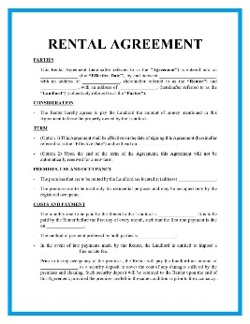 | Lease agreement (Rental agreement) – A document signed by both the landlord and the tenant. This shows the terms and rules for living in the property.
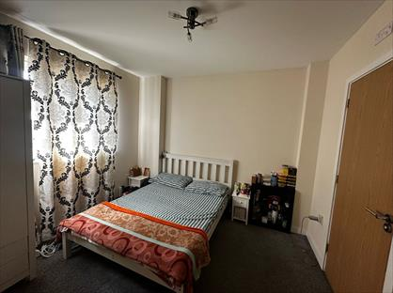 | Private rented property  Housing owned by landlords and rented to tenants. This can be a room with a shared bathroom and kitchen or a whole property.
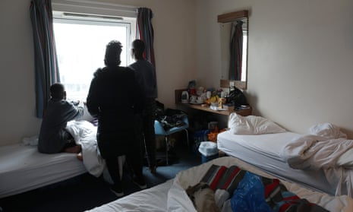 | Temporary accommodation A room normally used for a short time.
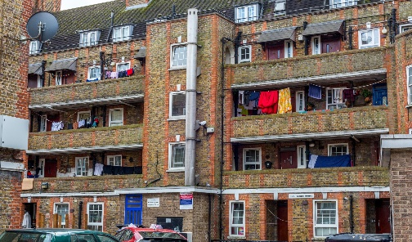 | Council housing – Flats or houses, normally for people with children, owned by the council ( sometimes called local authority).
 | Asylum accommodation – Temporary housing for those seeking asylum, often in hotels. Paid for by the Government until refugee status is given.
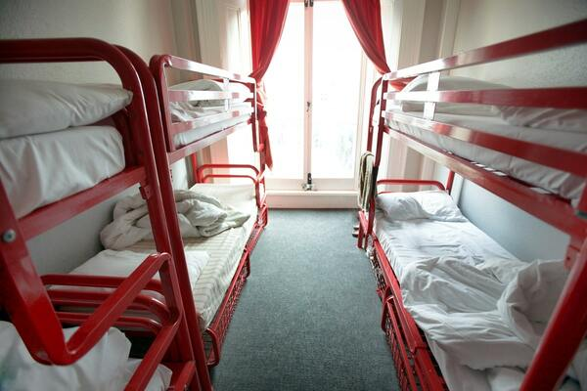 | Hostels – Many people all in the same room. Normally used as temporary housing for a short time.
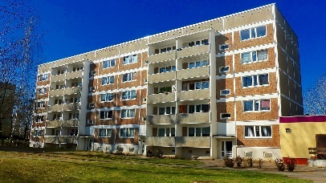 | House A building on its own land.  Flat Part of a building that contains many individual living spaces with their own bathroom and kitchen.
 | Rent The amount of money paid each month for housing to the Landlord.
 | Universal Credit  Money the UK Government pays for your housing if you are out of work or on low income.

Type of place to live

If you need a place to live, you can rent a room or a flat. You can stay in a:

Shared house – You have your own room. You share the kitchen and bathroom.
Room in a house – You rent one room.
Flat, apartment, or house - You may live alone or with your family.

Task 2 –Housing exercise using joining words

Joining Words – used to join two or more sentences together.
And adds similar information to the sentence.
.

Examples
"I have seen a flat, and a house."
"I want a flat, but I need a garden."

Sometimes you can use the conjuntion but or and.
The first gives additional information.
"The flat was small, and it had a big garden."
The second compares information. In the sentence below the size of the flat is compared to the size of the garden.
"The flat was small, but it had a big garden."

Complete the sentences using the conjunctions, also known as joining words, and or but.

I am living in a house, ………………….. the rent is too high.

I would like a flat with a dishwasher, ………………………. a washing machine.

There is a flat for rent, ……………………. it is too far from the station.

My rent is paid by Universal Credit, ………………… it goes straight to my Landlord.

I was living in a hostel, ……………………….. now I have found a room to rent.

My Landlord is putting the rent up, …………………….. I like the flat so I will pay it.

My house has a garden at the front ………………………. the back.

I am going to phone my council………………………. ask them for help with housing.

I just got my right to remain, ………………………… I have applied for Universal Credit to pay for a flat, ……………………………. I don’t know how quickly I will get it.

Task 3 – Finding housing
“There are many types of housing in the UK. You can live in a house or a flat. Some people rent from a landlord, but others live in council housing.

If you need help, you can ask friends or look online. Spareroom.co.uk and Roomgo.co.uk are websites that have rooms to rent, but there are lots of others.

Universal Credit can pay for your rent, so you do not worry about money, but apply as soon as you know you will need help paying rent. If you are working you will be expected to pay your rent from your wages, but if you are on a low income, you might get Universal Credit. “

Read the writing above. Underline all the joining words you have learnt about.

Now answer the following questions, try to use ‘and’ ‘but’ in your answers:

- What two types of housing are mentioned? Use ‘and’ in your answer.

- How can you find housing?

- How can you pay for your housing?

- Talk to your partner and think of other ways you might be able to find housing.

Charities that may be able to help with housing:
Refugee Council refugeecouncil.org.uk
London Lettings Network https://lettingsnetwork.housingjustice.org.uk

Task 4 – Visiting housing

When you find a property call the landlord to go and see the property.

Vocabulary
Deposit – money paid to a landlord which they keep until you leave their property.
Rent – the monthly amount paid to the landlord for the use of their housing.
Council Tax – money paid for services the council supply e.g. collecting rubbish.

- In pairs practice making a call to the landlord.

Landlord: Hello
Tenant: Hello, I am calling about the room you have for rent. I saw a sign in the local shop window, and I wanted to ask if it’s still available.
Landlord: Yes, it is.
Tenant: Do you need a deposit, and how much is it?
Landlord: Yes, you must pay a month’s rent as a deposit. You get this back when you move out if you have kept the room in good condition.
Tenant: Will you take Universal Credit as payment for the room?
Landlord: Yes, but only if it is paid directly to me. You must pay the deposit and the first month’s rent on the day you move in. You can’t move in until the Universal Credit payments are set up.
Tenant: Does the rent include bills and WiFi?
Landlord: It includes council tax, electricity, gas and water but not WiFi. You have to set up and pay for WiFi.
Tenant: Can I come and see the property next week?
Landlord: No, I can only show you the property today after 7pm.
Tenant: OK I will be at the property at 7.30pm today and I will bring my friend.

- Underline the joining words in the conversation.

- Can you think of any other questions you need to ask?

Task 5 – Review

- What is Universal Credit?

- Who signs a lease agreement? Use the joining word ‘and’ in your answer.

- Give two ways to look for housing using conjunctions.

- Make a sentence with ‘but’ and a sentence with ‘and’ about what you would look for when finding housing.

- Move these letters to find names from the vocabulary in Task 1.

- oshlte | - cncilou | - hsoue | - oraytepmr

