Task 1 – The library

A library is a building with many resources. Mainly books but also computers, which have online resources and members of staff who can help you find what you are looking for. You can read books either in the library or borrow them and take them home if you become a member, but you will need to return them.

Vocabulary

I’d like to borrow a book.
I’d like to return a book.

Can I use the computers to search for online resources?
Can I become a member?

Match the vocabulary to the meaning:

borrow |  | Give, put, or send (something) back to a place or person
return |  | A supply of something.
member |  | Take and use (something belonging to someone else) but you will return it.
resources |  | To belong to a group.

The present simple tense
The present tense is used to speak about things that are happening now, or things that happen regularly.

I go to the library every Tuesday.
I read books at bedtime.

Future tense
Used for things we are planning to do.

- Will + verb

Used in two ways:

- Describing something we know or think will happen.
It will be windy tomorrow. There will be rain. I will take an umbrella.

b. Making a decision about what you will do right away.
Which book should I borrow? I will borrow the funny one

2. Be + going to + verb

Used for something you have decided in the past, that you will do or will happen in the future.

We are going to the library on Saturday.
We are going to look for the new Harry Potter book.

Rewrite these present tense sentences using the future tense:
Example:
I borrow books.
I am going to borrow books.

I return books on Saturday.

____________________________________________________

I am at the library.

____________________________________________________

I use online resources.

____________________________________________________

Task 2 - Joining the library
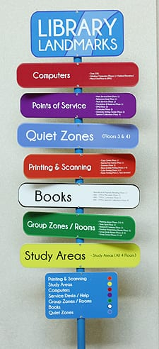
You need to become a member of the library to use their resources. You can do this by completing a form. You will also need to show something with your name and address on.
Write, using future tense, what you are going to show the library that has your name and address on.

Practice filling out a form for the library:
Title: Mr Miss Ms Mrs Other:
Surname
First names
Date of birth
Postcode
Email address
Telephone Number

Task 3 – Jobcentre

Vocabulary

Low income – only having a little amount of money each month

Employers – the people you work for

CV - a document that tells employers about your work and education

Skills – things you can do e. g. . typing, building

Experience – where you have worked or volunteered

Interviews – when you meet your employer to talk about the job, your skills and experience before you get the job

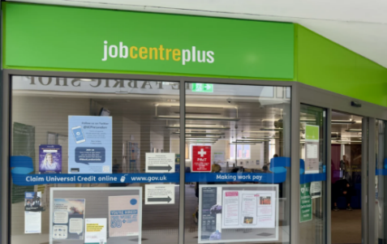
The Jobcentre, also called Jobcentre Plus, is a place to help people find work, build their skills, practice for interviews and claim for Government money if they are not working or on low income. All their resources are free to use.

At the Jobcentre you can look for jobs on computers and ask for help to find work.
At the Jobcentre you can write a CV. For most jobs you will need a CV.
At the Jobcentre you can prepare for job interviews with the help of the people who work there, you can practice with them.
At the Jobcentre you can get help with how to get money if you do not have a job or are on low income. They can help with your application.
At the Jobcentre you can learn new skills which can help you find work.

Complete 5 sentences about what you are going to do in the Job Centre using the future tense. Start each sentence with ‘I will’.

Example:
- I will look for jobs in the Jobcentre.

Decide which of the following sentences are written in present tense and which of them uses future tense. Circle your answer

I am at the Jobcentre. | Future | Present
I am going to write my CV. | Future | Present
I will help you prepare for your job interview | Future | Present
I don’t have a job. | Future | Present
The Jobcentre is going to teach me new skills. | Future | Present



Task 4 – Citizens Advice

- You can go to Citizens Advice at their offices or online to get free help.
- You can get help with money, housing, work and immigration.
- They will keep what you say confidential (private).
- They can help everyone.
- They can help in other languages.

Questions. Answer these questions about Citizens Advice:

1. | You can contact Citizens Advice in their offices. | true | false
2. | Citizens Advice can give you money for food. | true | false
3. | You can email Citizens Advice | true | false
4. | You can get advice in other languages. | true | false
5. | You can’t ask them about immigration. | true | false
6. | You have to pay for help from the Citizens Advice. | true | false

Underline the words that show that the passage below is written in the future tense. The first one is done for you.

The Abbas family are going to arrive in the UK. The are going to learn English when they arrive. They are going to need help. I will take them to the Citizens Advice offices so they will be able to get advice in their own language about immigration.

Task 6 – Review

- Why would it be a good idea to join a library?

- If you want help to write your CV, where can you go, and what things should be on your CV?

- You have questions about your immigration status, but your English is not good, who can you contact for help?

- Give the different ways you can contact Citizens Advice?

- You are learning English, where can you get books to help you learn?

Write 2 things that you are going to do after this lesson using the future tense.

1.

2.

